Contents

I. Introduction 2

a. Purpose 2

b. Scope 2

c. References 2

II. Test Areas and Specifications 3

a. Features to be tested 3

III. Test Cycle Transition 5

a. Entry Criteria 5

b. Exit Criteria 5

c. Continuation Criteria 5

d. Abnormal Termination 5

IV. Milestone Deliverables 6

V. Test Deliverables and Execution 7

a. Key Participants 7

b. Test Reports 8

e. Test Release Management 9

VI. Environmental Needs 10

a. Harware and Software 10

b. Productivity and Support Tools 10

c. Test Environment Configuration 10

VII. Planning Risks and Contingencies 11

VIII. Approvals 11

# Introduction

* Quickgarde is a prototype that simulates a website add-on that detects and reports cyber bullying occurrences. Quickgarde can detect harmful posts wether they are in English or Tagalog. Quickgarde is implemented together with a dummy social networking site for simulation purposes.

## Purpose

* + This Test Plan is aimed to ensure whether the System Objectives and Functional Requirements are met.
  + To test Quickgarde functions and its dummy social networking site
  + Record The results of the testing activities
  + Improve User friendliness of the system for its end-users

## Scope

* + This is a Test Plan for Quickgarde functions and its Dummy Social Networking Site
  + Testing will be based on the available use cases on Test Link

## References

* + Using NLP(Natural Language Processing) to Analyze Cyber-Bullying ( Final Paper submitted for Software Development, Software Requirements Specification, Use Cases)
  + Knowledge of The Team Members about their project

# Test Areas and Specifications

## Features to be tested

|  |  |  |  |
| --- | --- | --- | --- |
| **UC No.** | **UC Name** | **Test Type** | **Build** |
| **UC 01** Admin Authentication | | Functional, GUI, | Iteration1, Iteration2 |
| **UC 02** Admin Views the Report | | Functional, GUI, | Iteration1, Iteration2 |
| **UC 03** User Registration | | Functional, GUI, | Iteration1, Iteration2 |
| **UC 04** User Authentication | | Functional, GUI, | Iteration1, Iteration2 |
| **UC 05** User subscribes to another user | | Functional, GUI, | Iteration1, Iteration2 |
| **UC 06** User Creates Post | | Functional, GUI, | Iteration1, Iteration2 |
| **UC 07** User Views Post | | Functional, GUI, | Iteration1, Iteration2 |
| **UC 08** User Comments on a Post | | Functional, GUI, | Iteration1, Iteration2 |
| **UC 09** User Updates Profile Information | | Functional, GUI, | Iteration1, Iteration2 |
| **UC 10** Sytem Detects a cyberbullying event | | Functional, GUI, | Iteration1, Iteration2 |
| **UC 11** System Reports a Cyberbullying event | | Functional, GUI, | Iteration1, Iteration2 |
| **UC 12** User Visits the Web Application URL | | Functional, GUI, | Iteration1, Iteration2 |
| **UC 13** Logout User Account | | Functional, GUI, | Iteration1, Iteration2 |
| **UC 14** Logout Admin Account | | Functional, GUI, | Iteration1, Iteration2 |
| **UC 15** User Views his/her Profile | | Functional, GUI, | Iteration1, Iteration2 |
| **UC 16** User Views Comments | | Functional, GUI, | Iteration1, Iteration2 |
| **UC 17** User Visit another Account | | Functional, GUI, | Iteration1, Iteration2 |
| **UC 18** Admin View Registered Accounts | | Functional, GUI, | Iteration1, Iteration2 |
| **UC 19** User Delete his/her comments | | Functional, GUI, | Iteration1, Iteration2 |

|  |  |  |
| --- | --- | --- |
| **UC 20** System Send Notification to the User | Functional, GUI, | Iteration1, Iteration2 |
| **UC 21** User Received Notification from the  System | Functional, GUI, | Iteration1, Iteration2 |
| **UC 22** Admin Send Email | Functional, GUI, | Iteration1, Iteration2 |
| **UC 23** User Send Friend Request | Functional, GUI, | Iteration1, Iteration2 |
| **UC 24** User Accept Friend Request | Functional, GUI, | Iteration1, Iteration2 |
| **UC 25** User Change their Username | Functional, GUI, | Iteration1, Iteration2 |
| **UC 26** User Change their Password | Functional, GUI, | Iteration1, Iteration2 |
| **UC 27** System Detect Cyberbullying should not  maximize three times | Functional, GUI, | Iteration1, Iteration2 |
| **UC 28** System Categorize Detected Violation | Functional, GUI, | Iteration1, Iteration2 |

# Test Cycle Transition

## Entry Criteria

* + Requirements are Documented and Approved (Test Pla and Test Case)
  + Completed Build release
  + Build is Ready for Testing

## Exit Criteria

* + All Test Cases are Completed
  + No more errors found after Regression Testing

## Continuation Criteria

* + Errors found in previous iteration is fixed
  + Project Manager requests Test Execution

## Abnormal Termination

* + Project Manager terminates test
  + Error that causes failure to continue with the test
  + Incomplete deliverables such as use cases or test cases that could cause time wastage

# Milestone Deliverables

|  |  |  |
| --- | --- | --- |
| Deliverables | Date Start | Date End |
| Test Plan | February 20, 2017 | February 21,2017 |
| Test Plan review and revision | February 23, 2017 | February 23, 2017 |
| Iteration1 | | |
| Test Cases | February 27, 2017 | March 6,2017 |
| Test Execution – Iteration1 | March 13, 2017 | March 22,2017 |
| Test Reports and Logs – Iteration 1 | March 23, 2017 | March 23, 2017 |
| Review/Revise Test Cases | March 24, 2017 | March 24,2017 |
| Iteration2 | | |
| Test Execution – Iteration2 | March 27, 2017 | April 4, 2017 |
| Test Reports and Logs – Iteration 2 | April 5, 2017 | April 5, 2017 |

# Test Deliverables and Execution

## Key Participants

|  |  |  |
| --- | --- | --- |
| Name | Role | Note |
| Rolando Aurelio Talag | Project Manager | Iteration1: QSS141-03-9, -10, -27, -28, -29, -31, -33, -34, -37  Iteration2: QSS141-03-20, -22, -28, -31, -34, -36, -37, -38, -39, -41, -43 |
| John Lloyd B. Briones | Project Developer | Iteration1:QSS141-03-4,-5,-6,-7,-8, -11, -12, -13, -14, -15, -20, -22, -23,  Iteration2: QSS141-03-4, -5,-6,-7,-8,-9, -10, -24, -27, -29, -33 |
| Denzel Oribiana | Project Analyst | Iteration1: QSS141-03-16, -17,-18, -19, -21, -24, -26, -30, -36, 38, -40, 42, -46  Iteration2: QSS141-03-11,-12,-13,-14,-15,-16, -18,-21, -23, -47, -48, -49, -50, -51, -52 |
| Victor Manuel Serrano | Project Designer | Iteration1: QSS141-03-32, -39, -41, -43, -47, -48, -49, -50, -51, -52  Iteration2: QSS141-03-16, -17, -19, -26, -30, -40, -42, -44, -45, -46 |

## Test Reports

Test results will be evaluated at the end of the test execution of every build. Test reports and Test Summaries will be submitted to the Project Manager and Project Developer for further review

1. Pie Chart for Iteration 1 and 2 (50 test Cases)

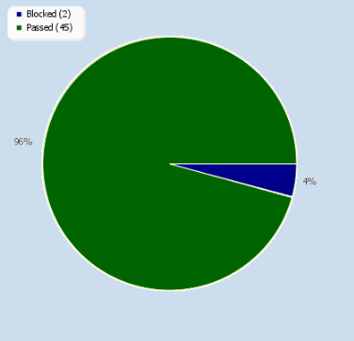

1. Results Per Test Suite

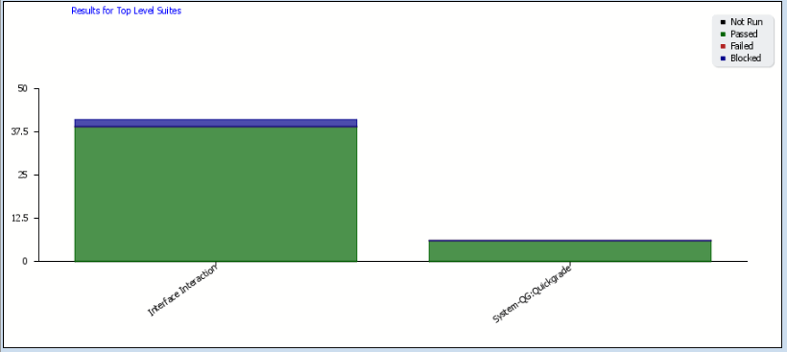

1. Overall Status per iteration

Build.PNG

1. Results per Test Suite

Suite.PNG

## Test Release Management

Test Release will be handled by the Project Manager and Project Developer, after every build

# Environmental Needs

## Harware and Software

|  |  |  |
| --- | --- | --- |
| Resource | Configuration | Installed OS, Software |
| Test Server (Localhost) | CPU: Intel i3 4005u  4GB Ram | Windows 10 64-bit  XAMPP Control Panel  Apache Tomcat 8.0.35 |
| Client Machine | CPU: Intel i3 4005u  4GB Ram | Windows 10 64-bit  Google Chrome |

## Productivity and Support Tools

|  |  |  |  |
| --- | --- | --- | --- |
| Tool’s Purpose | Tool Name | Vendor or in-house | Version |
| Test Management | Testlink | Open Source | 1.9.14 |
| Documentation | Microsoft Word | Microsoft Office | 2017 |
| Revision Control System | GitHub | GitHub |  |

## Test Environment Configuration

|  |  |  |
| --- | --- | --- |
| Configuration Name | Description | Impleented in Physical Configuration |
| Test Server (Localhost) | Run Test on Localhost Server | XAMPP Control Panel |

# Planning Risks and Contingencies

|  |  |  |
| --- | --- | --- |
| Risk | Mitigation | Contingency(Risk Is Realized |
| Lack of time to test | Adjust Schedule to and plan ahead in order to leave allowances in the schedule | Re allocate work in order to increase work speed |
| Aditional Changes or updates | Have a clearly defined scope for each build | Follow the scope of the build additional changes can be included on subsequent builds |
| Late Delivery of software to be tested | Have allowances in the schedule to accommodate potential risks | Increase human resource on various testing phase in order to accommodate the lost time |

# Approvals

|  |  |  |  |
| --- | --- | --- | --- |
| Name | Role | Signature | Date |
| Talag, Rolando Aurelio | Project Manager |  |  |
| Briones, John Lloyd | Project Developer |  |  |